Item 1
Burgundy Polo Shirt
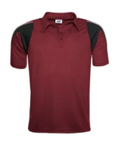

Item 2
*PLAIN BLACK Shorts / Tracksuit Bottoms or Sports Leggings
The entire material must be plain black with no patterns or other colours. If the item is branded, the logo must be very minimal in size.
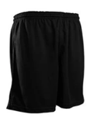
Item 3
White ankle length socks & Burgundy Football Socks

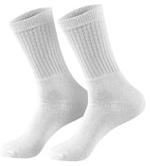
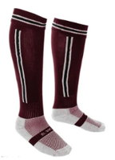

Not Allowed
Jewellery

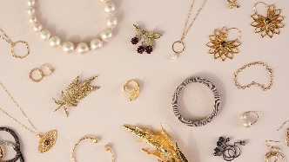

Physical Education Kit List
Item 4
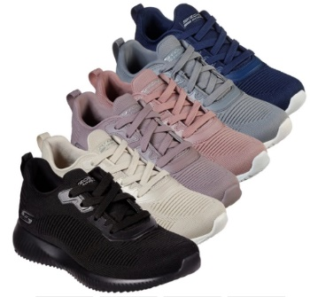
Suitable Sports Trainers

Item 5
Rubber Moulded Studs or Blade Football Boots
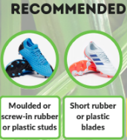

Item 8
Football Shin Pads

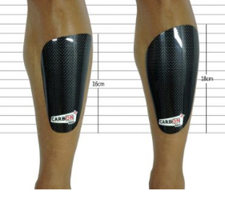
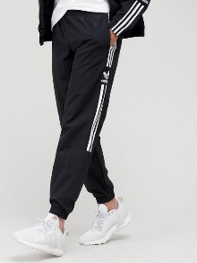
Not Allowed
Large Logos / Lettering

Item 9
COMPULSORY FOR KS3
Gum Shield
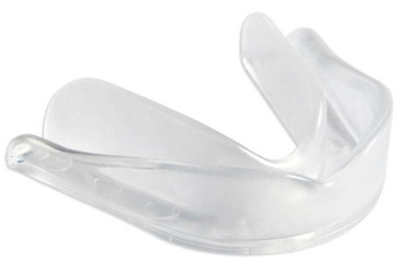
Can be bought from the PE office when needed

OPTIONAL
Burgundy Rugby Shirt
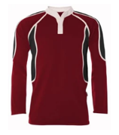
OPTIONAL
Burgundy Fleece
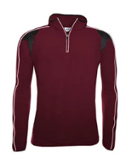
Not Allowed
Nike Pro 3”/7.5cm Shorts (or any other branded shorts of similar length)
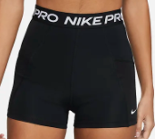

Not Allowed
School Shoes / Vans/ Converse / Nike Air Force Ones / Skate shoes etc.
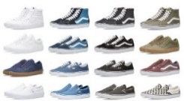

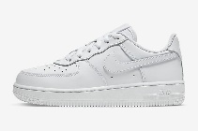

Association for Physical Education – Safe Practice: in Physical Education, School Sport and Physical Activity Advice

PERSONAL EFFECTS, INCLUDING JEWELLERY AND CULTURAL OR RELIGIOUS ADORNMENTS
2.14.7 Schools have a duty of care to ensure students are able to participate actively without unnecessarily endangering themselves or those working around them.
2.14.8 A clear and consistent applied policy for the removal or personal effects should be in place. The Association for Physical Education (afPE) strongly recommends the practice of removing all personal effects at the commencement of every lesson to establish a safe working environment. This applies to all ear and body piercings, including retainers and expander earrings.
2.14.11 Exclusion from a lesson should be avoided at all times if a student is unable to remove personal effects or the taping is deemed unsatisfactory.
2.14.12 Staff should always give a verbal reminder to students and, where necessary, visually monitor the group and/or individuals. Particular vigilance maybe required when dealing with body jewellery.
2.14.13 Body jewellery should be removed to a safe standard. Where staff observe body jewellery being worn during any Physical Education, school sport or physical activity, they should stop the activity and initiate procedures to make the situation safe.
2.14.14 Medical bracelets: Recent developments in the manufacture of medical-aid wristbands have resulted in products with an acceptably low risk factor (i.e. soft materials, Velcro fastenings). Such items should be acceptable for most Physical Education, school sport and physical activities without the need for removal. However, these bracelets need to be regularly checked by the owner to make sure there is no hard or sharp edges that may cause injury. Where there is any concern, the bracelet can be covered with tape, padding or soft, sports-style wristband.
2.14.15 Fitness watches and wristbands monitoring activity should be removed for Physical Education, school sport and physical activity sessions, clubs and activities.
2.14.16 Religious artefacts need to be removed or made safe. Health and safety law would usually take precedence over equality law because of the implication of the “safety of others” and the specific duty set out in the health and safety at work act 1974.
    - Sensory aids:
The decision as to whether it is safe or possible to wear glasses or hearing aids will usually be determined by the nature of the activity. Activities involving physical contact and full game situations may not be appropriate. For example, England Rugby (RFU) allows the wearing of glasses (in non-contact games) up to the under 8 age group, while the Football Association (FA) leaves this to the referee’s discretion up to the age of 14.
Where the sensory aid needs to be worn for safe participation by the individual, then the staff, wherever possible, need to amend the activity (such as providing more space and time) or the equipment (such as using a soft ball instead of a harder one) in order to try to make the participation while wearing a sensory aid as safe as possible for the wearer and others in the group.
2.14.20 Long hair should always be tied back with a suitably soft item to prevent entanglement in apparatus and to prevent vision being obscured.
2.14.21 Nails need to be sufficiently short to prevent injury to self and others.

Association for Physical Education – Safe Practice: in Physical Education, School Sport and Physical Activity
Ninth Edition
ISBN:978-1-909012-47-9
Braunton Academy Jewellery Policy

- Earrings and jewellery must NOT be worn for PE, school sport or physical activity. All earrings and jewellery must be removed prior to the lesson as these items pose a potential hazard not only to the wearer but also to other students.

- Taping - Braunton Academy does NOT accept the taping of earrings as a fully effective safety measure for students to take a full and active part in Physical Education, school sport and physical activity here at the Academy. Where sufficient front and back taping is used for students unable to remove earrings our policy is that these students will be able to only take part in specific isolated physical activities/practices where the risk of harm to themselves or other students is extremely low. During other times when the risk is higher, students will be given alternative roles in the lesson such as referee, coach, equipment organiser, team analyst etc. Students that do not use taping will not be able to take any active part in the lesson and will be given alternative roles in the lesson such as referee, coach, equipment organiser, team analyst etc.

- Where taping is utilised, the teacher supervising the group maintains the legal responsibility to ensure the taping is effective for purpose. Where staff consider the taping to be unsatisfactory to permit safe participation, they will need to consider alternative involvement in the lesson for the student.

- Teachers are not allowed to remove or tape the earrings for children. Children who cannot remove their earrings themselves – mainly due to the 6-week period after the initial piercing – must not take part in PE lessons or school sport.

- The use of retainers (Flat studs that retain the piercing when earrings or studs are removed) is becoming more common as a form of acceptable substitution where total removal is not possible. Provided these are flat and cannot cause damage if a blow or ball hits the side of the head, the level of risk is clearly reduced.

- Body jeweller: Staff should regularly ask whether any student is wearing body jewellery. The jeweller Physical Education, school sport or physical activity, they should stop the activity and initiate procedures to make the situation safe.

- Parents are advised to have their children’s ears pierced at the start of the summer holidays.

Please Note:
- Valuables - Students must not leave any valuables in the changing rooms. Students should hand in valuables to the PE office before the start of lessons; they will be locked away safely for them.

- Socks - Must be removed for floor gymnastics but must be worn for Trampoline.

- Asthma Sufferers - Inhalers should be taken to lessons.

- Injury or Excuse Notes - Requests to be excused from full participation in a Physical Education lesson should be signed by a parent/carer. If Students are excused from participating in Physical Education they will still be involved in lessons as substantial learning can still take place. Students must therefore always change into Physical Education kit and bring appropriate additional warm/waterproof clothing.

